Problem 3 – Digits

You are given a matrix of digits. The matrix contains some patterns that form digits. Your task is to find these digits and calculate their sum:
The digit patterns are as follows:
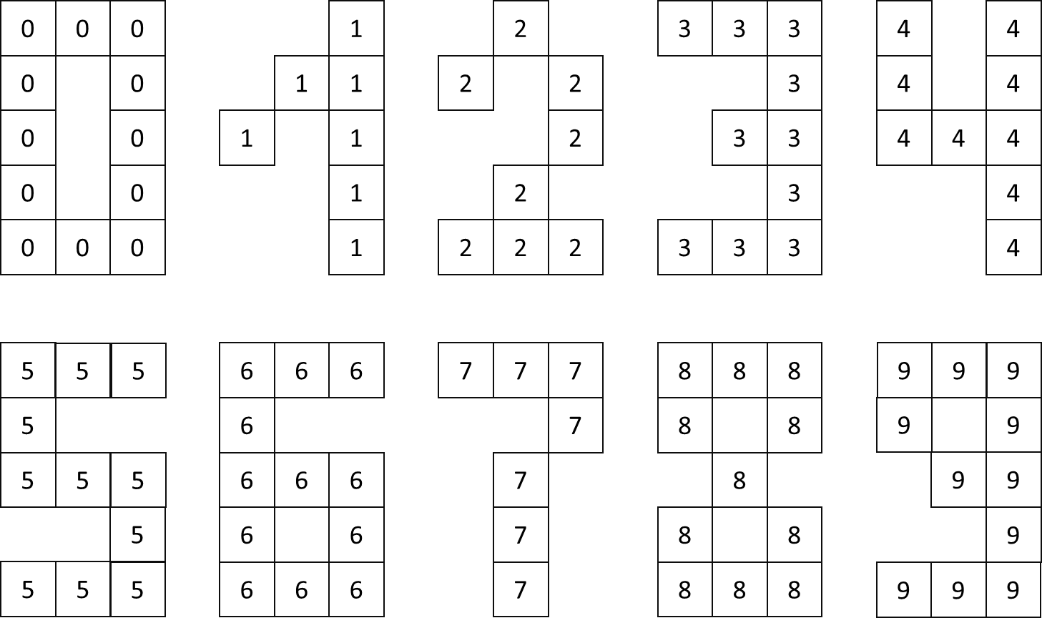
Each digit patterns is formed by the same digit:
- The one-digit pattern is formed from cells with the digit one
- The nine-digit pattern is formed from cells with the digit nine
- Etc…

The size of the patterns is constant and always has the given form.

Example:

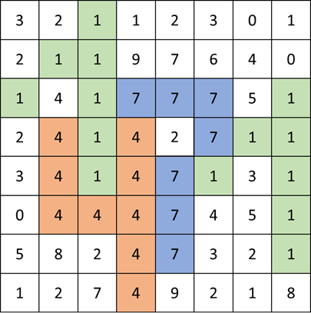
The digit patterns are marked in green, red and blue
Four digit patterns are found – twice one-digit, one seven-digit and one four-digit pattern.
The sum is 1 + 1 + 4 + 7 = 13

Input
On the first line of the console you will find the number N – the number of rows and columns of the matrix
On the next N lines you will find exactly N digits, separated by a space. These are the digits of the matrix.
The input data will always be valid and in the described format. There is no need to check it explicitly.

Output
The output data consists of a single line. It should contain the sum of all the digit patterns in the matrix

Constraints
- N will always be greater or equal to 5 and less or equal to 1250
- The values in the matrix will always be digits
- Allowed working time for your program: 0.3 seconds.
- Allowed memory: 32 MB.

Examples
Input | Output | Explanation
5  1 1 1 1 1  1 1 1 1 1  1 1 1 1 1  1 1 1 1 1  1 1 1 1 1 | 3 | The one-patern is found three times.  The sum is 1+1+1 = 3

Input | Output | Explanation
6  9 9 9 2 2 2  9 9 9 2 2 2  9 9 9 2 2 2  9 9 9 2 2 2  9 9 9 2 2 2  9 9 9 2 2 2 | 22 | The nine-pattern is found twice and the two-pattern is also found twice.  The sum is 9 + 9 + 2 + 2 = 22

Input | Output | Explanation
8  3 2 1 1 2 3 0 1  2 1 1 9 7 6 4 0  1 4 1 7 7 7 5 1  2 4 1 4 2 7 1 1  3 4 1 4 7 1 3 1  0 4 4 4 7 4 5 1  5 8 2 4 7 3 2 1  1 2 7 4 9 2 1 8 | 13 | This is explained in the example above

